**Name: Vijay Kota**

**Roll no: 150096724074**

**Cohort: Mark zuckerburg**

App from Google appsheet

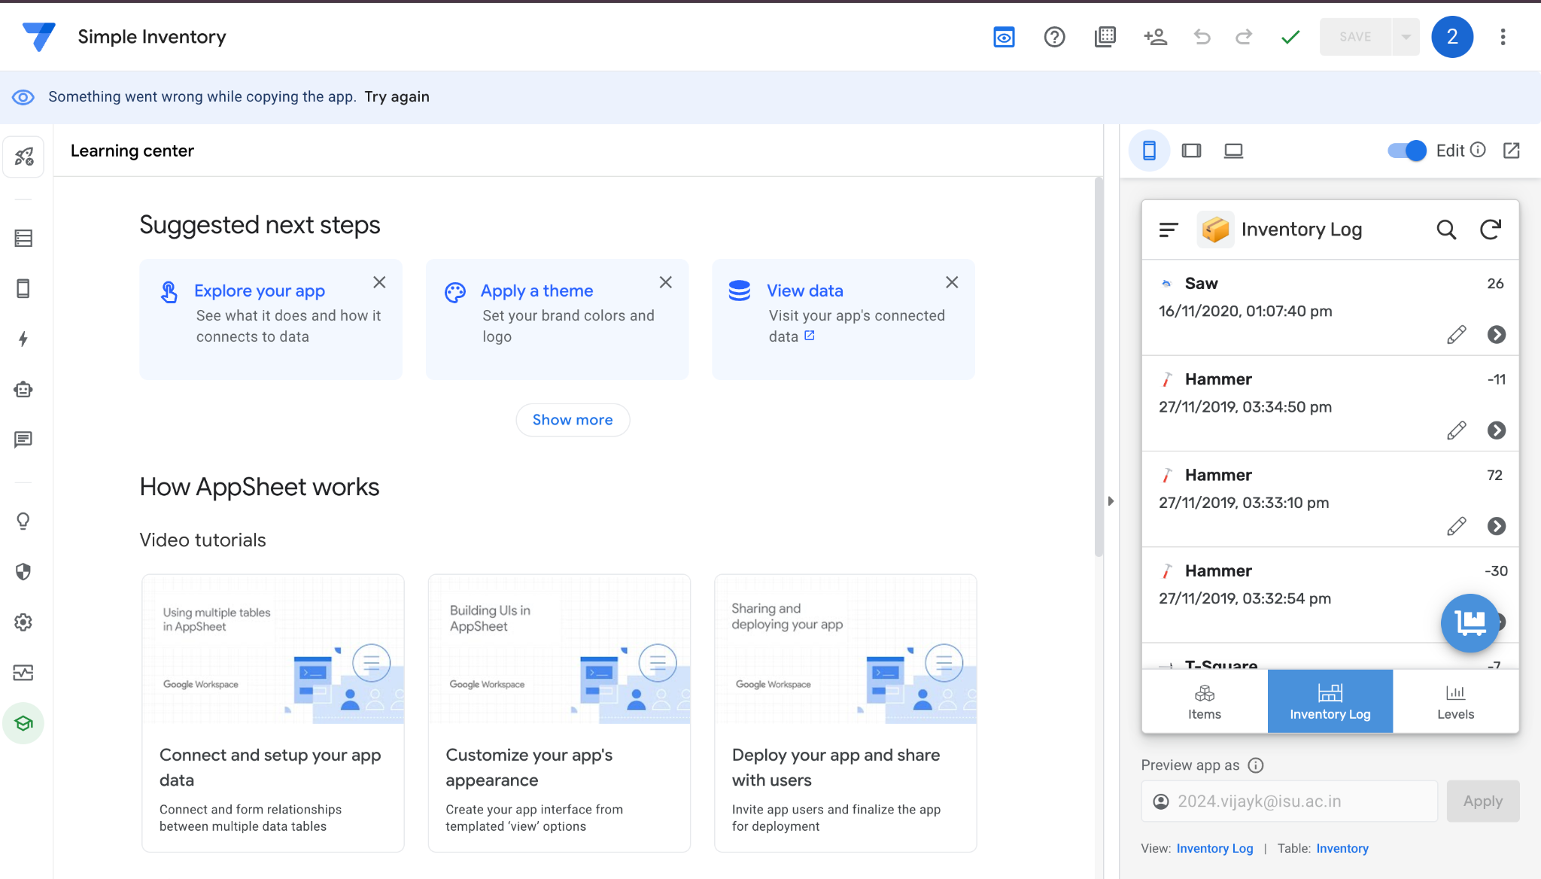

Database